



Community Safety Plan

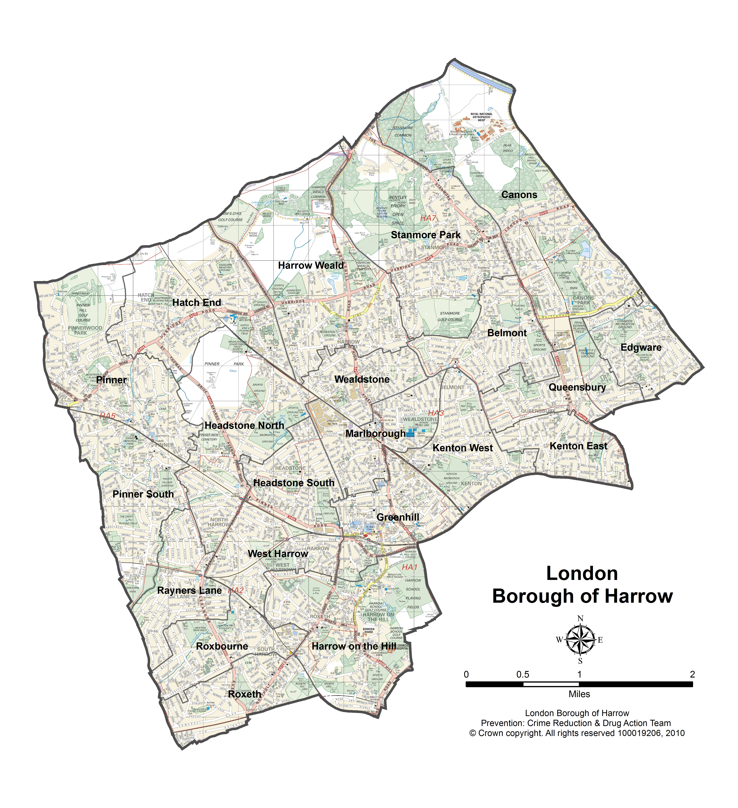
2011 – 2014

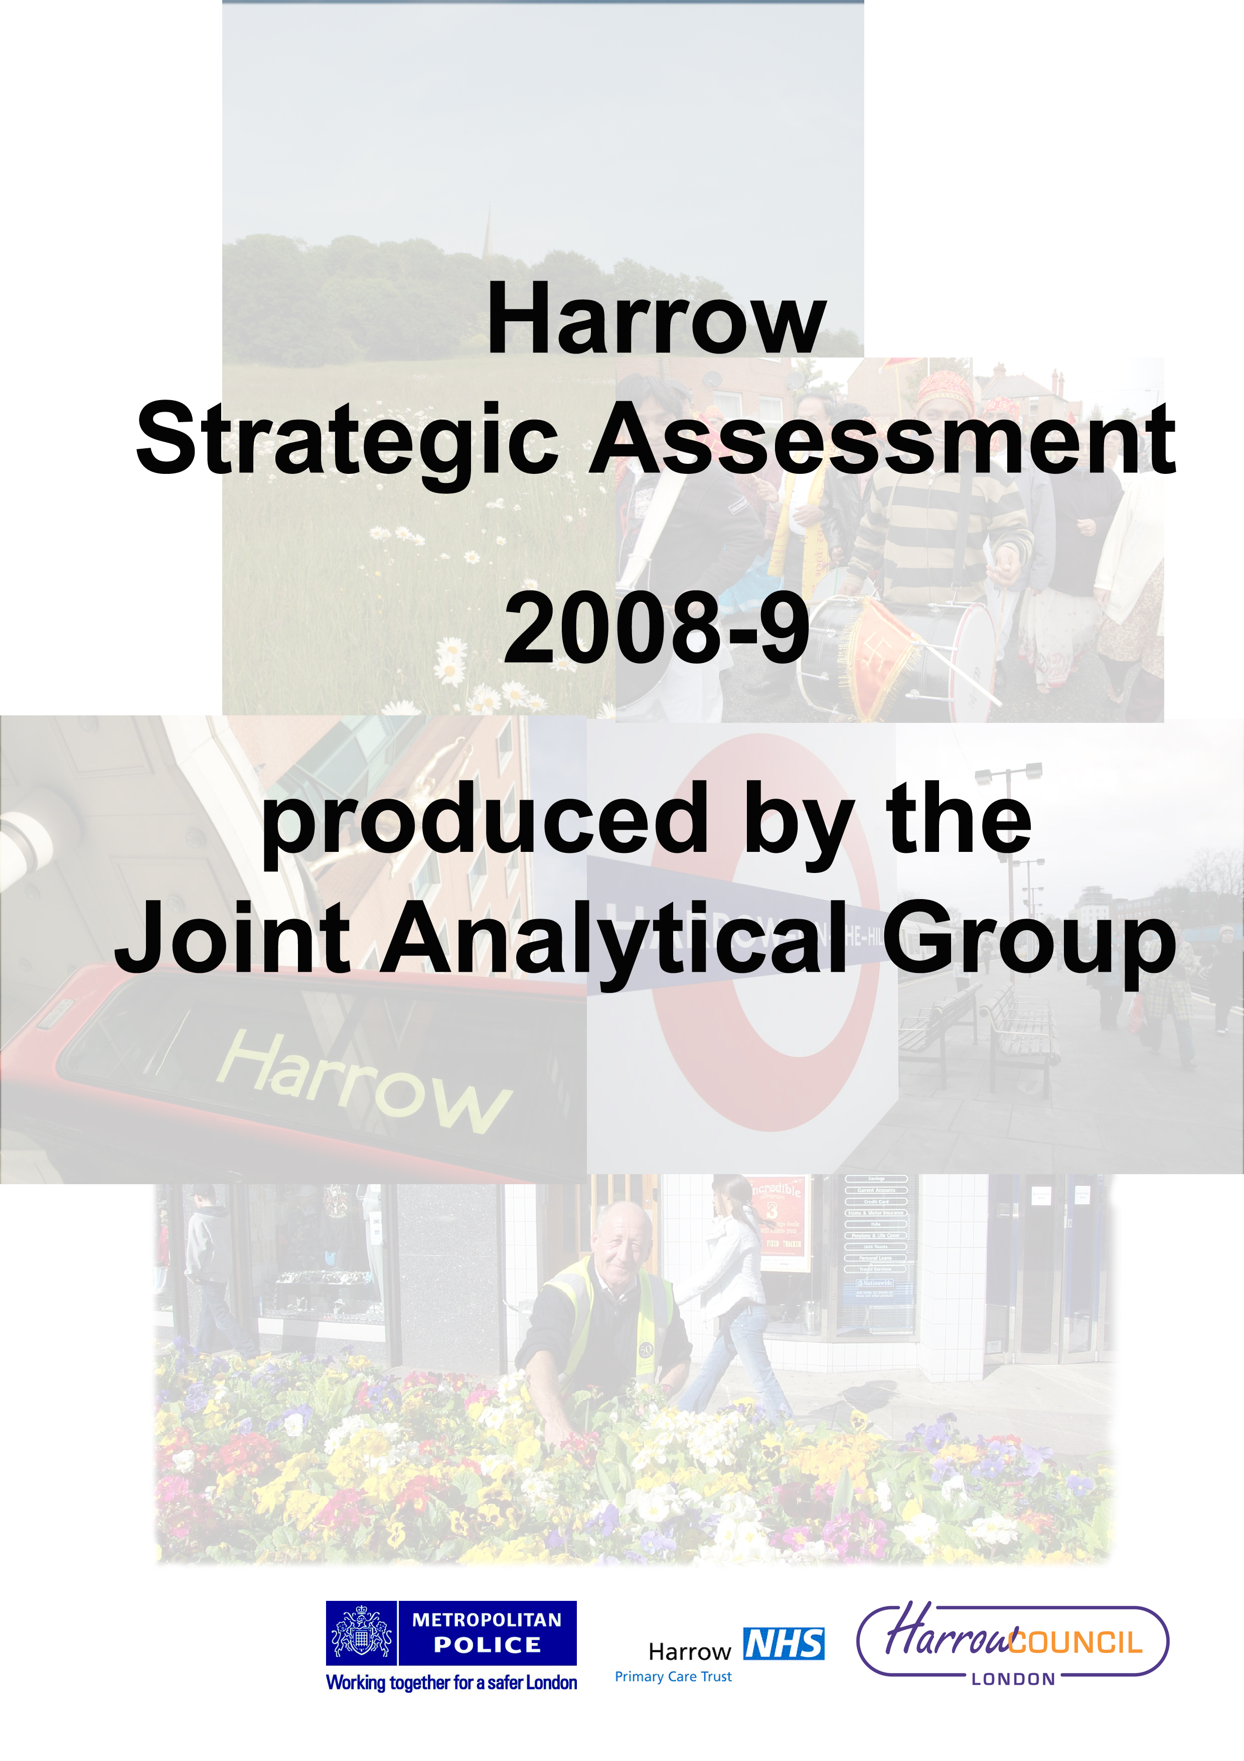




Foreword by Borough Commander; Chief Executive and Portfolio Holder for Environment and Community Safety

Welcome to Harrow’s Community Safety Plan covering the three years 2011/12 to 2014/15.

The Community Safety Plan sets out how the Police, the Council, the Probation Service, the NHS, the Fire Service, the voluntary and community sector and individuals can all contribute to reducing crime, disorder and anti-social behaviour and keeping everyone in Harrow safe.

Community Safety is about:

Police action to detect and arrest offenders, to deter crime, to give advice to keep people and property safe and to reassure communities that their safety concerns are addressed,

Council action to safeguard vulnerable people –children, young people and adults, to provide activities that engage young people and divert them from crime and anti-social behaviour to reduce offending and re-offending, to keep the Borough clean and tidy, to operate public CCTV, to intervene to reduce anti-social behaviour, to reduce domestic and sexual violence and to reduce race, hate and religious crime and reduce community tensions;

Probation action to protect the public by supervising offenders in the community and to reduce re-offending;

NHS action to provide substance misuse education and treatment services;

Fire Brigade action to help people stay safe from fire and other emergencies, in the home, at work and in London’s other buildings, to respond to emergencies, to make sure London is prepared for a major incident or emergency; and to take urgent enforcement action when we believe public safety is being put at risk in buildings;

Voluntary and Community action to support individuals at risk of offending and communities at risk of crime and anti-social behaviour; and

Individual action to become a Neighbourhood Champion, to take responsibility for your own behaviour and actions, to report crime and anti-social behaviour and to support each other if threatened by crime.

As this range of activity shows, community safety is a complex series of issues that cannot be successfully tackled by any agency working alone so representatives of all of the groups listed meet together as the Safer Harrow group to plan how best to reduce crime and anti-social behaviour. Our ideas and actions for 20111/12 and the two years beyond are set out in this plan.



Dal Babu Michael Lockwood Councillor Phillip O’Dell
Borough Commander, Chief Executive Portfolio Holder, Community Safety
Harrow Police Harrow Council Harrow Council
Contents

Foreword by Borough Commander / Chief Executive / Portfolio holder 2
Introduction: What is the Community Safety Plan? 4
The nature and future of Safer Harrow 5
Funding 6
Consultation with Harrow residents and steakholders 7
Emerging Issues 9
Summary of Harrow’s crime and disorder problems 10
Performance: 2007/08 – 2010/11 10
Recent performance and trends 11
Safer Harrow’s crime and ASB priorities 12
Residential burglary and other serious acquisitive crime 13
Violent offences 14
Anti social behaviour (ASB) 15
Domestic violence and violence against women and girls 17
Young people – reducing offending and victimisation 19
Drug misuse 20
Reducing reoffending 22
How the Plan will be implemented and monitored 23
Appendix A 24
Significant recent and future criminal justice changes 24
Safer Harrow’s consultation methods 27

Introduction: What is the Community Safety Plan?

The Police and Justice Act 2006 requires Community Safety Partnerships to produce Community Safety Plans. Community Safety Plans build on the analysis of crime trends and totals that is carried out by the Community Safety Partnership each that leads to the production of a Strategic Analysis. The Community Safety Plan sets out how the partnership intends to respond to the local crime landscape. This Community Safety Plan covers the period 2011/2014 although in much more detail for 2011/12 than the later years as the plan will be refreshed each year to reflect up to date conditions.

This Community Safety Plan has been produced using detailed analysis to ensure that it reflects the priorities for Harrow and all those who live, work, and learn in our borough, and those who visit.

This Plan also sets out development areas for the Community Safety Partnership, which locally is called Safer Harrow, to ensure it remains a strong and sustainable partnership with a strategic focus and effective performance management.

This purpose of this document is not to analyse crime and Anti-Social Behaviour (ASB) problems in Harrow. A detailed analysis of recent crime patterns can be found in the Strategic Assessment published in March 2011 and on which the actions proposed in this plan are based. Instead the focus of this plan is on how to tackle crime and ASB problems.

Purpose of the Safer Communities Plan

This Plan describes the work of the Council, the Police and partner agencies to reduce crime and create safer and stronger communities across Harrow by:

- Identifying priority community safety issues and geographical areas based on our strategic assessment.
- Working in partnership with other organisations to keep the Borough clean, green and safe
- Communicating with and involving people in Harrow to address the issues that matter most to them.
- Mainstreaming community safety activity within the Council’s service plans and those of partner agencies.
- Leading and supporting Safer Harrow in delivering safer communities.
The nature and future of Safer Harrow

What is Safer Harrow?

Safer Harrow is the name of the Community Safety Partnership that was set up following the 1998 Crime and Disorder Act. Partnership approaches are largely built on the premise that no single agency can deal with, or be responsible for dealing with, complex community safety and crime problems and that success will come through joint working.

The Partnership comprises:

- Harrow Police
- Harrow Council
- Harrow Probation
- Voluntary sector organisations
- Harrow Fire Service
- NHS Harrow
- The Metropolitan Police Authority (MPA)

Partners bring different skills and services to Safer Harrow. The police and the probation service, who both have as their core role the reduction of crime and disorder, play a very active role in Safer Harrow while for other partners, community safety is a less central issue. However, all contributions are important and the range of different contributors to improving community safety in Harrow means that extensive coordination is needed. This is reflected in number and specialisation of the co-ordination and strategy groups through which Safer Harrow addresses its concerns.

In terms of formal structure or governance, Safer Harrow comprises a number of forums that facilitate delivery and coordination.

- At a strategic level, community safety is coordinated by the Safer Harrow, which includes senior managers from the partner agencies and meets quarterly;
- At an operational level, a high level body called the Joint Agency Tasking and Coordinating Group (JATCG) meets monthly to discuss operational issues that are persistent, topical or impact on large numbers of residents.
- The Anti-Social Behaviour Action Group (ASBAG) meets monthly to tackle lower level anti-social behaviour problems of individuals or of particular areas.
- Multi-Agency Public Protection Arrangements (MAPPA) targets the most serious sexual and violent offenders and comprises Police, Probation and the Prison Service.
- The Drug Action Team (DAT) commissions treatment, education and preventative services for people with substance misuse problems
- The Multi Agency Risk Assessment Committee (MARAC) co-ordinates work to address repeat victimisation from domestic violence
- Domestic Violence Forum – partnership group for practitioners
- Hate Crime Forum (HCF) is the lead agency working on race faith hate crime issues. It meets quarterly and is composed of police, community representatives and council officers.
- A number of other agencies have a duty to cooperate including Children’s Services and the Youth Offending Team

These formal groups are supported by practitioner groups that share information and good practice, groups that bring the experience of victimisation or public concerns to the Partnership and regular contact between and within agencies.

Safer Harrow is only able to influence certain community safety and criminal justice services that are delivered locally. Prisons and courts for example, are managed and administered centrally.

Financial savings from partnership interventions will often not return to organisation making the investment and sometimes not to organisations within the partnership at all such as the Prison Service and Courts Service who can benefit financially from Safer Harrow’s interventions.

The future of Safer Harrow

In December 2010, five secretaries of state, including the Home Secretary and the Justice Secretary, set out the government’s view about the future of community safety partnerships. The government intends that partnerships will continue to be statutory, but wants them to be more action focused. Regulations around partnerships will be reduced in the next year although their impact currently is slight and the impact of this change is not expected to be significant.

Funding

The Government’s public sector spending plans involve significant reductions in funding for all the agencies involved in criminal justice over the next three years. How these reductions will impact on the ability of individual agencies to support the community safety agenda will only be known as detailed budgets are drawn up. However, for the current year, some examples of the decisions already made give an indication of the impact that changes to funding will have. For the Police, the overtime budget has been reduced by 28% which will have an impact on the flexibility to respond to peaks in demand for police activity. Similarly, the loss of a £148,000 fund for discretionary spending will reduce the number and extent of local initiatives to address specific local issues.

For the Fire Service, although the overall budget for London has been reduced by some £39m, the impact has been offset by the use of reserves to ensure staff numbers are maintained. However, a local initiatives fund of £72,000 has been closed.

For the Council, spending reductions have been experienced in both general support and specific grants for particular areas of work. For example, the Youth Offending Team’s direct grant from the Government has been reduced by £150,000 while the budget for generic young people’s services will be reduced by £750,000 resulting in a reduction in the range, quantity and quality of services than will be able to provided. The loss of funding to the Council also means that, in turn, the Council’s support for the voluntary and community sector will reduce affecting a range of services that the Community has come to rely upon.

The NHS nationally has an increased cash budget but has a target to save £20bn over the next 5 years. Locally, the Primary Care Trust has a deficit which requires compensatory spending reductions of 15% in all services.

The budgets of the Police, Probation and Fire Services are focused exclusively on community safety work. In addition, significant mainstream resources from Harrow Council, and the Primary Care Trust, contribute towards reducing offending behaviour in the borough.

Consultation with Harrow residents and stakeholders

Consultation is undertaken regularly by the various partners in Safer Harrow including relating to day to day problems as well as on broader issues. Consultation also takes place on what community safety issues should be prioritised and what actions should be taken to address particular issues.

As part of the Community Safety Plan, it is necessary to consult residents on what they think the priorities should be. The agencies that make up Safer Harrow engage in a variety of methods of consultation to ensure that residents’ views are reflected in what they prioritise and how they tackle crime and ASB problems. A full list of the consultation methods and the consultation undertaken in the last year is included in Appendix A.

How important do residents rank crime and ASB compared to other issues?

The chart below shows the extent to which respondents rated a variety of issues as important. Respondents ranked the level of crime as the single most important issue. Similar high rankings of the importance of crime and ASB have been obtained in the recent past with other methods, for example the Place Survey in 2009 and 2008.

Chart 1: Issues considered very important by Harrow residents
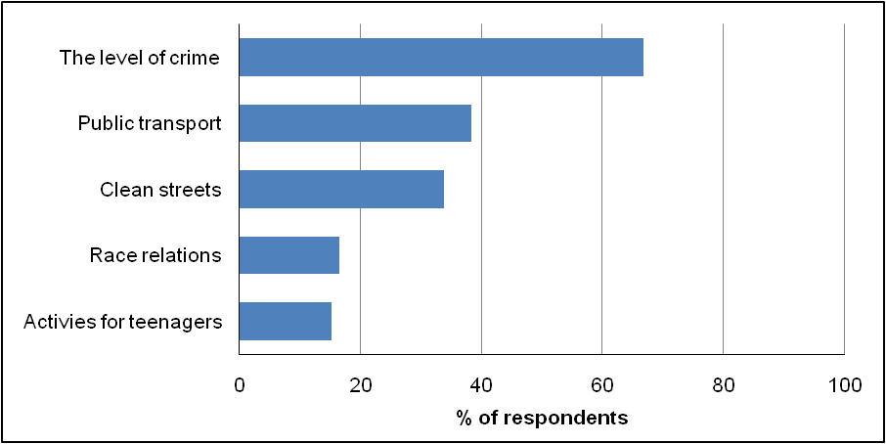

Source: Residents Panel, October 2010: 1190 people who are broadly representative of the Borough as a whole

Which crime and ASB issues do residents want prioritised?

Residents in Harrow are regularly asked which crimes and types of ASB they want prioritised by the Police, Harrow Council and other partners. The methods used include surveys and focus groups.

At focus groups, participants initially ranked violent crime as the most important, but during subsequent discussion in which participants focused more clearly on what was a problem in their local areas, ASB was identified as a more frequent problem. In particular, litter and fly-tipping were frequently mentioned. Hate crime and domestic violence were not ranked as high priorities.

The chart below shows the extent to which residents were concerned about different types of ASB in Harrow. A comparatively high proportion of residents were concerned about litter and fly-tipping. Vandalism and intimidation/harassment were also concerns. Issues such as abandoned vehicles and prostitution were less of a concern.

Chart 2: Which types of ASB residents were very concerned about

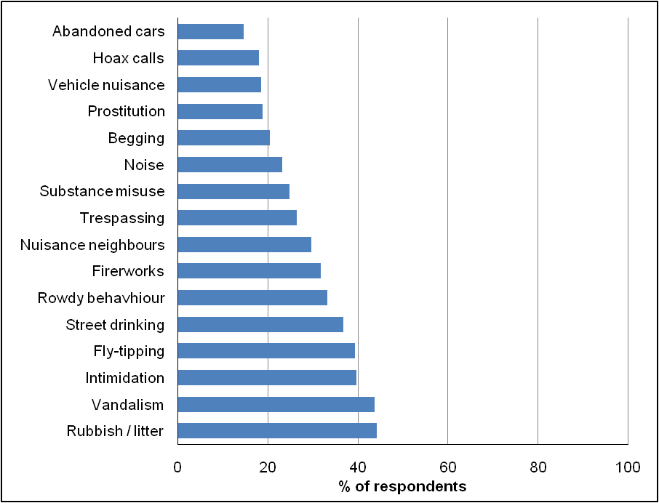

Source: Residents’ Panel, October 2010

The Public Attitudes Survey, which a high quality survey commissioned by the Metropolitan Police, and produced data for each borough, suggests that the Police are concentrating on issue that matter to Harrow residents. Almost 80% of respondents thought that the Police understood issues that affect their community and 70% thought that the Police deal with things that matter to people in their community. Overall 85% of residents were satisfied

Emerging Issues

A Police analysis of emerging issues has identified the following topics as having an impact of community safety:

- Olympics and Paralympics 2012
- Reductions in public expenditure
- Identity Fraud
- Increasing unemployment and, especially, youth unemployment
- Welfare Benefit and housing tenure changes
- Closure of Harrow Magistrates’ Court
- New criminal justice legislation
- Changes to sentencing to promote rehabilitation
- Introducing payment by results for offender management
- Centralisation of Police Human Resources and Finance services
- Changes to the Police and other organisations’ operational buildings and sites
- The role of the Mayor of London as Police Commissioner
- Most of the individual agencies in the Partnership are restructuring in some way….

These issues have informed the development of the actions described in this plan although the detailed impact of many is not yet known.

Summary of Harrow’s crime and disorder problems

Performance: 2007/08 – 2010/11

The table below summarises changes in the level of crime and other criminal justice indicators from 2007/08 before the start of the 2008/09-2010/11 Community Safety Strategy and 2010/11, the final year of the Strategy.

Crime and anti-social behaviour indicators
Crime/ASB type | 2007/08 | 2010/11 | Change | Percentage change
Total crime | 14074 | 14968 | 894 | 6 ⬆
Common assault | 660 | 832 | 172 | 26 ⬆
Personal robbery | 469 | 398 | -71 | -15 ⬇
Residential burglary | 1541 | 1798 | 257 | 17 ⬆
Theft from vehicle | 1768 | 1637 | -131 | -7 ⬇
Theft of vehicle | 548 | 364 | -184 | -34 ⬇
Snatch and pickpocket | 537 | 499 | -38 | -7 ⬇
Criminal damage | 394 | 317 | -77 | -20 ⬇
Personal robbery | 469 | 398 | -71 | -15 ⬇
Young first time entrants | 164 | Expected 1/6/11
Offences committed by young people | 564 | Expected 1/6/11 | 339 – total number of people found guilty
Problem drug users in treatment | 391 | Expected in July. Estimate 410
Incidents recorded on buses | 1346 | 911 | -435 | -32 ⬇
Racist offences | 117 | 227 | 110 | 94 ⬆
Domestic violence | 920 | 1270 | 350 | 38 ⬆
Incidents on trains and tubes | 781 | 491 | -290 | -37 ⬇
Fly-tipping (publicly reports) | 2075 | 2625 | 550 | 26 ⬆
Graffiti (public reports) | 185 | 166 | -19 | -10 ⬇

In 2010/11, there were 14,968 crimes in Harrow (officially referred as total notifiable offences (TNOs)) compared to 14,074 offences in 2007/08, an increase of 6%. Most of this increase took place in 2008/09 when total offences increased by 7%. Total crime has fallen since 2008/09.

What crimes and ASB have gone up?

Several categories of crime showed substantial increases comparing 2007/08 with 2010/11. These include:

- 17% increase in residential burglary. This figure has increased relatively evenly over the three year period
- 26% increase in common assault, the least serious of the three main assault categories
- Publicly reported fly-tipping has gone up, but the increase took place in 2008/09. Public reported fly-tipping has fallen in the last two years.

What crimes have gone down?

Many of the crimes that are discussed in the partnership have gone down over the last three year. These include:

- 15% decrease in personal robbery
- 7% decrease in theft from
- 24% reduction in Racist and religious hate offence in 2010/11

Who commits crime and ASB in Harrow?

Crime is committed by people from all communities and every way of grouping and categorising them. In Harrow, some groups are more likely to offend than others. For most crime types, offenders are disproportionately young and disproportionately male. In relation to their number in the population, Asians have low rates of offending and Black residents high rates of offending. However, the profile of offender varies considerably between crime types with, for example, robbery being committed by much younger offenders than burglary.

Victims of crime in Harrow

Victims are more demographically varied than offenders in terms of age, ethnicity and gender. Younger people are more likely to be victims than older people, but the relationship between age and risk of victimisation is relatively weak. Males and females have similar levels of victimisation, but these vary between offence types with, for example, males more likely to be victims of violence in general, but females more likely to be victims of domestic violence.

Recent performance and trends

The Police set targets for reductions in particular crime types and also targets for the rate for resolving those crimes. Resolving is measured by the Sanction Detection rate which means the number of offences for which a judicial outcome is achieved such as a conviction or a caution.

The most recent performance figures for the year April 2010 to March 2011 show that the sanction detection rate in Harrow for all crime types exceeded target and, in some cases, by a significant margin.

On crime reduction over the same period, in six crime categories, the number of incidents increased rather than reduced while in four, the target reductions were achieved and exceeded. This mixed picture includes substantial reductions in the important categories of robbery, gun crime and violence with intent while some of the increases are of very small numbers of incidents but which against low baselines show as large percentage changes.

Safer Harrow’s crime and ASB priorities

There are limited resources available to tackle crime and disorder problems in Harrow, as elsewhere, and these resources are best used by taking account of trends and crime patterns as well as concerns of residents.

The priority for Safer Harrow is to reduce crime and anti-social behaviour so that everyone in harrow stays safe and has the best possible quality of life. For 2011/2014 and based on the information in our Strategic Assessment, we will concentrate on:

- Residential burglary and other acquisitive crime
- Violent crime
- ASB
- Domestic violence
- Youth offending
- Drug and alcohol misuse
- Re-offending

Residential burglary and other serious acquisitive crime

Residential burglary is theft, or attempted theft, from a residential building where access has not been authorised.

The Police and their partners intend to commit considerable resources to reducing residential burglary and other acquisitive crime over the next three years. The items outlined in this section are Partnership approaches rather than internal activities of Harrow Police, where much of the impetus for reducing residential burglary comes from.

The Partnership activities over the next three years that will impact on residential burglary and other acquisitive crime include:

Crime prevention and communication

- Continue the Smartwater initiative that offers free property marking to all households in the Borough that ask for it. The initiative is intended not only to deter burglary at each property at which the making system is deployed but, through mass distribution, to make Harrow an unattractive place for burglars to operate in.

- Consider funding for locks and security for victims aged over 65.

- Build on communication activities around prevention as a very high percentage of burglaries in Harrow involve obtaining access through unlocked doors and windows – and particularly those adjacent to single story extensions.

- Continue to focus on drug treatment. A high proportion of acquisitive crime, particularly residential burglary, is committed by people with a substance misuse issue. Increasing the number of drug users in treatment and improving the effectiveness of treatment is likely to reduce acquisitive crime. Details of the Partnerships plans around drug treatment are in a later section.

• Continue the emphasis on crime prevention by working closely with Housing and the Registered Social Landlords to make properties more secure.

• Crime reduction communication campaigns in known hotspot areas

• Provide crime prevention advice to the owners of vulnerable properties in the hotspot locations

• Introduce an integrated offender management scheme to reduce re-offending.

Enforcement activity

• Continue with high-visibility Police patrols in known hotspot areas to deter offenders, as well as to gather intelligence about individuals in the area likely to be committing these offences

• Actively target known offenders and hotspot areas through pro-active operations, to reduce the number of offences

- Continue to work with other boroughs including Hertfordshire and Brent to gather intelligence about possible offenders committing burglaries in Harrow

- Target handlers of stolen goods to restrict the sale of stolen property

Violent offences

Harrow has relatively low levels of violent crime compared to other London boroughs, but violent crime is still a concern of Harrow residents and one incident can have substantial impact not just on the victim but also on the victim’s family and friends as well as the wider community.

Many of the partnership actions related to reducing violence are related to alcohol, which is one of the main drivers of violent crime. Domestic violence is discussed as a separate priority. Some of the Partnership actions for the three year period include:

- Maintain the number of CCTV cameras in Harrow Town Centre and Wealdstone, the two dominant hotspots for violent crime. In the last year, 13 street cameras have been installed.

- Licensing – the Police Reform and Social Responsibility Bill, when enacted, will give Harrow Police and Council additional powers for tackling alcohol related disorder connected to licensed premises. The Council will continue to monitor alcohol related disorder and invoke the new powers when appropriate.

- Better use of accident and emergency data. From June 2011, Northwick Park will record assault (and other) codes for A&E admissions. This is potentially valuable data which will enable the Partnership to gain a better understanding of violent offences in Harrow and improve how the Partnership responds.

- Probation is developing approaches to Integrated Offender Management (IOM) which seeks to reduce re-offending. IOM requires the active support of all of the agencies that give support to vulnerable people through, for example, the provision of accommodation, training and support into employment and treatment and support to address substance misuse issues

- Response Project. Harrow is one of three pilots in 2011 for a new model of response policing. It is intended that there will be a more effective response to significant and immediate calls. As of May, Harrow is in the design phase.

- Gang activity – The Council and the Police working together have been successful in a concerted approach to addressing gang membership with targeted non-contact ASBOs and youth service interventions. This work will continue to reduce gang influence.

Anti social behaviour (ASB)

Many residents in Harrow experience ASB at some point. This could be fly-tipping, graffiti, litter, noise, nuisance neighbours, vandalism or youths hanging around. For some residents, levels of ASB can have a significant adverse impact on their quality of life. The partnership has a wide range of tools at its disposal for tackling ASB and intends to continue to prioritise ASB.

Some of the key partnership actions over the next three years include:

- Continue the Pride in Harrow Weeks of Action. These are multi-agency week-long events which focus on a particular area to address crime, anti-social behaviour, environmental concerns, and issues such as untaxed cars

  - Integrate the Council and Police Anti-Social Behaviour Teams. This will start from October 2011 and is likely to result in benefits around information sharing and more effective problem solving. A “risk based case handling” system will be introduced to help prioritise responses.

- The tools available to the Police and Council for dealing with ASB will change following legislation in winter 2012 with the new tools in place to use in Harrow by 2013. Some of the key changes are:

- The abolition of ASBOs and other court orders and their replacement by two new tools: the Criminal Behaviour Order and the Crime Prevention Injunction
- The creation of a Community Protection Order for dealing with place specific ASB
- The creation of a single police power for dispersal around ASB
- A greater emphasis on rehabilitation and restorative justice for perpetrators of ASB

The Partnership will keep up to date with these changes and make effective use of the new tools.

- Possible modification of the Safer Neighbourhood Teams (SNT). A proposal had been made to modify the configuration of SNTs in Harrow to match the incidents of crime and anti-social behaviour.

- Ensure that there are effective responses to the Community Trigger (which gives victims and communities the right to require agencies to deal with persistent anti-social behaviour). This is likely to introduced in 2012

- The effectiveness with which Harrow Council deals with reports by members of the public on problems such as fly-tipping, litter and graffiti will be improved with the introduction of the Streets and Ground Maintenance Project. This new system will enable problems to be recorded more rapidly and accurately and improving how they are dealt with.

- Re-focussing the role of Neighbourhood Champions and providing greater support. It is hoped that a borough-wide conference will take place in 2011.

- The creation of the Joint Intelligence Unit will improve information sharing and joint problem solving.
- Continue operations around Wealdstone where youth workers have been embedded into Safer Neighbourhood team patrols to provide a range of responses to the issues presented by young people.

- Maintain CCTV coverage in and around Harrow Town Centre. This will help to reduce ASB, a high proportion of which takes place in the Town Centre

Domestic violence and violence against women and girls

Following two years of significant increases in the number of domestic violence offences, there was a fall of 2% in the number of domestic violence offences in 2010/11. Despite this decrease, Harrow still has relatively high levels of domestic violence, when compared to its relatively low levels of offending for overall crime in comparison to other London Boroughs.

One of the major changes from the last Strategy has been the broadening of the focus from domestic violence to include other offences such as sexual violence, prostitution and harassment, trafficking and stalking as set out in the Government’s “Call to End Violence Against Women and Girls: Action Plan” published in December 2010. This document follows the previous Government’s attempt to broaden the focus. This section reflects these changes.

The strategic objectives for DSV can be grouped under four broad headings of Prevention, Provision, Partnership and Perpetrators. The following section lists some of the key actions; however for more detail refer to the ‘DSV Strategic Framework and Action Plan 2011-2013’.

Prevention

- Continue the work which work which was relatively small scale until 2010 of raising awareness of domestic and sexual violence and attitudes to violence against women and girls. A broad range of activities is covered including work in schools and community events such as Under One Sky and Pride in Harrow.

- Public awareness campaigns including raising awareness addressing forced marriage and female genital mutilation.

- Specialist training for 350+ professionals in Harrow including faith, community, voluntary and statutory services

Provision

- Mainstream funding for at least the minimum staffing levels considered necessary for Harrow of three Independent Domestic Violence Advisors and a post to support the Multi-Agency Risk Assessment conference (MARAC)

- Continue and extend actions to maintain public awareness of DSV. A broad range of activities are included for this purpose

- Try to establish an Independent Sexual Violence Advisor (ISVA) who work with clients at high risk of sexual violence, specifically those under 18 years old.

- Maintain the Sanctuary Scheme, refuge beds and the participation in the West London Rape Crisis Centre at least until March 2012 when the funding situation will be reviewed

Partnership

- Continue monthly Multi Agency Risk Assessment Conference (MARAC) meetings but increase training about the MARAC and embed links with the Multi Agency Public Protection Arrangements

- Ensure that DV and VAWG are comprehensively identified and effective tackled once identified. Emphasis on this area increased in 2010 and will continue throughout the strategy. Actions include:

- ensuring that there are clear referral pathways across agencies
- providing partners with risk assessment tools
- providing training to managers and front line staff.

- Ensuring that DV and VAWG are effectively identified, reported and tackled in all communities in Harrow. A range of actions will take place to ensure that this happens. This will include organising cultural and community events and working with other organisations to remove the stigma attached to reporting DV and VAWG

- Establish within the new Children’s Services Operating Model’s Access Team risk assessment tools and safeguarding procedures related to DSV to ensure high risk cases are identified and handled effectively

- The continuation of the recently created DV Network. This will involve newsletters for DV professionals and best practice sharing sessions

- Continue effective data sharing between police and probation in identifying perpetrators on license when the police go to premises

- Continue and extend actions to maintain public awareness of DV. A broad range of activities are included for this purpose

- A recovery programme for victims and their children is planned, depending on funding

- Try to establish an Independent Sexual Violence Advisor (ISVA) who work with clients at high risk of sexual violence

- Domestic homicide reviews come into force on 13 April 2011

- Better data collection and analysis to identify what works best is addressing and preventing domestic violence and repeat victimisation.

Perpetrators

- Work with neighbouring London boroughs to explore the possibility of joint commissioning and shared services. Harrow is already considering making use of Barnet’s newly commissioned programme for perpetrators of DV

- .Continue effective data sharing between police and probation in identifying perpetrators on license when the police go to premises.

Young people – reducing offending and victimisation

The overall aim of the Partnership is to reduce offending and re-offending among young people. There are going to be changes both in the national framework of delivering services to reduce youth offending as well as locally.

The Partnership provides direct support to young people in a number ways with the aim of helping young people prosper in education, work and the community and to minimise offending.

The Youth Offending Team (YOT), is the primary vehicle for preventing young people from re-offending, and will continue to provide a range of programmes aimed at a wide range of offenders from first time entrants to persistent offenders but a number of other agencies also play a key role.

Some of the key actions or programmes for the next three years are:

New Model for Children’s Services

- During October 2011, the YOT will be part of a new operating model which is to be introduced for Children’s Services. This will model will create a single “front door” for all services and it is expected to deliver better outcomes for young people. Support services to young people will be provided from Children’s Services rather than the YOT and provide YOT workers with a wider range of support

- The new operating model will centralise commissioning across Children’s Services broadening the number of voluntary sector agencies which YOT can work with

- The New Model will involve working more closely with the Police and Probation, with greater information sharing. A revised information sharing agreement has been produced.

- Positive activities will be commissioned centrally and be accessible across the Partnership

Youth Offending Team

- Other agencies will continue to show their commitment to youth offending by maintaining their contribution to the YOT through secondments or in kind deployment

- There will be a reduction in voluntary sector commissioning by YOT in line with its reduction in funding

- The YOT Management Board will be incorporated directly into the Safer Harrow Management Board, raising the profile of youth offending issues

Other agencies

The Connexions service supports young people and places information about crime and anti-social behaviour amongst a wider set of information and support services covering, for example, work and careers, health and relationships and learning

Drug misuse

The national framework around reducing drug misuse has changed significantly in the last year and will continue to change during the period covering the Community Safety Plan. Most of these changes will have an impact at local level.

In December 2010, the government launched its new drug strategy, 'Reducing Demand, restricting supply, building recovery: supporting people to live a drug-free life'.
The 2010 Strategy sets out a different approach to preventing drug use. The strategy:

- puts more responsibility on individuals to seek help and overcome dependency
- places emphasis on providing a more holistic approach, by addressing other issues in addition to treatment to support people dependent on drugs or alcohol, such as offending, employment and housing
- aims to reduce demand and supply
- increases the role of local agencies in reducing drug misuse
- aims at recovery and abstinence.

There is a range of drug treatment and support services available in Harrow, as detailed in the annual Adult Drug Treatment Plan. Some of the key actions for the next three years are:

Strategic shifts

- Maintain and extend strategic links to Safer Harrow Management Group, Health and Well Being Board, GP Consortium, Integrated Offender Management, New Arrival Task Force Group and Joint Strategic Need Assessment.
- Deliver the shift to prevention, recovery and social re-integration for drug treatment and rehabilitation services
- Develop a Borough-Wide “Building Recovery in Communities” plan, including the appointment of recovery champions, and the promotion of recovery care plans
- Increase the involvement of service users in treatment planning, commissioning and the collection of users’ feedback on treatment services.
Improve performance management and information sharing
- Embed Clinical Governance, Safeguarding and Information sharing in local systems, namely, CDRP, Health and Well Being Management Board, and Local Information Group.
- Improve performance management around treatment across the PCT, Council and the National Treatment Agency
- Put in place the Best Value Framework to make sense of data and information to improve outcome-based commissioning, Treatment Outcome Profile (TOP) compliance, audits of workforce competency and their training needs, financial management and a User/Carer Education, Training and Employment (ETE) scheme.
Extend partnership working
- Ensure that the new model of holistic services are up and running, with the goals of meeting the targets of PDU in effective treatment and successful completions, and improving partnership working and integrated care pathways.
- Adopt a multi-agency approach to develop assertive outreach and re-engagement services as a strategy to recruit and engage young people, BAME, and poly substance misusers and address the issues of crime, health and well being.
- Review and develop the Criminal Justice Project ranging from arrest and prison referrals, engagement and targeted intervention, rapid prescribing, specific poly drug use programme and psychosocial interventions to the enhancement of recovery and social reintegration.
- Set up satellite clinics at Probation Office, Monday to Friday to provide on site advice, information and triaged assessments.
- Establish strategic alliance with the goals of multi-agency co-ordination, information sharing and joint working protocols to meet the complex needs, in particular to safeguarding, hidden harms, dual diagnosis, primary care, pharmacist and the avoidance of A&E hospital re-attendances.
Develop commissioning
- Continue to develop collaborative, integrated and developmental commissioning with emphasis on dual diagnosis, management of poly-substance misuse and Tier 4 services.
- Ensuring that commissioning results in high level of service performance, in particular an increase in the number of all drug users in effective treatment,
Make treatment more holistic and focus more on recovery
- Implement the Borough-wide Recovery Plan, with the monitoring of successful completions, telling recovery stories, peer mentoring and advocacy, and the development of pathways to employment (i.e., multi-agency approach such as benefit agencies, Job Centre Plus, colleges, volunteer group and mutual aid groups).
- Promote carer support, family interventions and community engagement, addressing the wider issues of the impacts of substance misuse on children, families and communities.
- Invest in User-led support, advocacy, training, volunteer work and apprenticeship scheme, with the recognition of PLAN as an independent organisation to promote self-efficacy.
- Promoting family interventions and carer support addressing the broader impact of substance misuse on families with all key stakeholders of adult and young people commissioners and service providers
- Drive on the Rehabilitation Revolution agenda, with the consolidation of the Criminal Justice treatment service in the context of IOM, DIP restructuring, PPO scheme, DRR treatment and day programme and residential placements, with the goals of redesigning service and obtaining Best Value.
Improving training and skills
- Promote workforce development, with audit of skills and training and a retention plan to promote competency and high quality of delivery at all levels.
- Equip all staff with multi-skills to work flexibly with all types of substance misused, including stimulant use, cannabis and poly-substance misuse.

Reducing re-offending

The vast majority of crime in Harrow, as elsewhere, is committed by repeat offenders. The two main agencies for reducing re-offending are London Probation: Harrow, which is the lead agency responsible for reducing re-offending and the Youth Offending Team. Both agencies try to change the behaviour of offenders and help them lead positive lives in the community.

In terms of treating offenders, Probation provides services to offenders released from prison who served a sentence of one year or more and offenders who have been sentenced in the courts to a Community Order or a Suspended Sentence Order. The Youth Offending Team attempts to prevent young offenders from re-offending.

Some of the key partnership actions for 2011/2014 include

- The creation of Integrated Offender Management Scheme by the end of the summer 2011. This will entail bringing together the services that supervise offenders and those that help offenders to lead positive lives to provide a unified offer of support.

- Extend and improve partnership working. Probation already works closely with the Police in Harrow, but there is scope to extend this to JobCentrePlus, Housing and Adult Services.

- Finalise the protocol and process for dealing with DV offenders. In addition to this, Safer Harrow will look at the DV offender scheme in Barnet and consider making use of the scheme for Harrow offenders.

- Probation will continue to be a hub for partnership activity to drive data sharing, joined up service delivery and risk assessment

- Probation will continue to drive partnership programmes and one off schemes – for example, the Drugs Bus

- Community Payback – the use of offenders on community sentences to undertake projects of community value.

How the Plan will be implemented and monitored

The Community Safety Plan has been compiled by combining the action plans of the partner agencies. It will be submitted for adoption by Safer Harrow, the Council Cabinet and the full Council as it forms part of the Council’s policy framework.

The Plan will, however, be owned by Safer Harrow which is responsible for delivering reductions in crime and anti-social behaviour. Safer Harrow will monitor changes in both the crime rate and the sanction detections and, at the same time, progress on the projects set out in this plan. This will give oversight of the extent to which the activity that partners have undertaken to deliver has been achieved and also the impact that completed actions and projects make on the incidence of crime and anti-social behaviour.

As well as quarterly monitoring at safer harrow meetings, there will be an annual review of the Plan and whether the outline actions included for later years are still appropriate and should be worked up in greater detail. This will lead to updating the action plan for 2012/13 and 2013/14. Unless the updating results in seeking new strategic objectives, it is not necessary for further formal approval to be obtained from Cabinet or the Council.

This plan should be sufficiently robust to absorb the changes envisaged by Government in the administration of criminal justice as these have been foreshadowed in drafting this document. The risks facing the plan are to be found more in the impact of continuing reductions in resources rather than legislative or organisational changes and is a possibility of requiring an interim plan next year or the year after if there are no longer resources to enable Safer Harrow to fulfil its obligations.

As well as the strategic overview brought to crime and anti-social behaviour by Safer Harrow, the various sub-groups and specialist groups will be responsible for monitoring their own action plans and the results that those strategies achieve and reporting these to Safer Harrow. Safer harrow will therefore be well placed to identify the efforts made and the effect achieved of community safety activity.

Appendix A

Significant recent and future criminal justice changes

The table below identifies the changes already announced and their impact on partnership actions and decisions.

All of these changes will take place during the life span of the next Plan and so their potential impact should be considered by the Partnership in developing the Plan.

Change | When | Theme | Impact | Future actions
Publication of street level data in a standardised format | January 2011 onwards | Data | Residents could become informed about crime / ASB problems in their area and more demanding about a response. | Monitor monthly data and respond where hotspots identified when appropriate
More power to local communities. Government has indicated a direction of travel. Details not clear. Suggestions:  (1) Council tax rebates to active citizens  (2) Publication of information on what has been done to tackle crime/ASB  (3) Greater say in how money is spent in communities | Report 'Our Vision for Safe and Active Communities' published March 2011 | Third sector / citizen engagement | Possible increase in residents' involvement in crime reduction activities – but unclear if much funding available - also big variation between areas and crime types. | A more proactive stance by the partnership at identifying organisation in the voluntary sector that have demonstrated effectiveness in reducing crime / ASB problems
Community Trigger to give residents the power to compel local agencies to take action against local, persistent troublemakers. | Legislation Winter 2012. | Third sector / citizen engagement
Simplify ASB tools available to police and LAs. 18 formal powers to 5. | Legislation winter 2012. | ASB | Potentially simpler and additional tools to deal with ASB.
 | June 2011
  Remove regulations in order to free up local community safety partnerships
New drugs strategy. A more holistic approach to the individual with greater powers at local level. Less emphasis on harm reduction and more on recovery. | 'Reducing demand, restricting supply, building recovery: supporting people to live a drug-free life' published Dec 2010.  implementation of strategy March 2011 | Drugs | Deliver of drug treatment. Drug use one of the main drivers too acquisitive crime
Rehabilitation and sentencing  Integrated offender management between police, probation and local authorities | Green paper, Breaking the Cycle, Dec 2010. | Rehabilitation | Greater role for local authorities in providing, commissioning and coordinating work with agencies involved in rehabilitation  Payment by results  D of H to divert offenders with drug and mental health problems into treatment  More integrated approach to managing offenders
Reduction in regulations around community safety partnerships | June 2011 | Governance | More discretion in governance and role of partnerships, but much
New Crime Strategy previous strategy  'Cutting Crime - a new partnership' which ends in March 2010. | December 2010
Hospital to share non-confidential data with | April 2011 | Data | Useful data source that could aid identification and analysis of serious violence and alcohol related violence
Increase police and local authority control over licensing | Bill 2011, will come into effect 2012 | Alcohol /licensing | Improves Partnerships ability to reduce alcohol related crime and disorder – introduction through
Minimum cost to alcohol | Proposals April 2011. If necessary legislation 2012 | Alcohol / licensing | Potentially reduction in “binge” drinking
Funding of Partnership agencies:
Police
Probation
Local Authority
Fire Service
Abolition of MPA increased role of Mayor |  | Governance
Internal changes to the police. A cluster of changes including ability to charge for minor offences and review of remuneration |  | Internal policing
Councils to get new powers over (HMOs) requiring planning permission |  | Housing
Abolition of the PCT

More effective responses to anti-social behaviour'. – consultation document – proposes measures to enable residents to compel local agencies to tackle ASB – consultation ends 17 May 2011
Remove regulation from Community Safety Partnerships – end of June 2011
http://www.homeoffice.gov.uk/publications/about-us/corporate-publications/structural-reform-plan/march-11-monthly-update?view=Binary

Develop a programme of work to mobilise communities to get involved in keeping their neighbourhoods safe, including enabling and encouraging people to get involved and mobilising neighbourhood activists (end Mar 2011)

Support the implementation of rehabilitation reforms by promoting tools and approaches such as Integrated Offender Management to help the police, probation, local authorities and other partners to work together with the most damaging offenders, including drug users (end Mar 2011)

Determine implementation plans for the drugs strategy (end Mar 2011)

Improve the recording of hate crime, enabling a consolidated dataset of hate-related offences to be published in an open and standardised format (end Apr 2011)

Remove regulations in order to free up local community safety partnerships from unnecessary bureaucracy (end Jun 2011)

Develop and publish plans to spread best practice and information on which techniques are most effective for use by communities, police, their partners and courts at preventing and cutting crime, working with the Ministry of Justice (end Jun 2011)

Develop and publish supporting actions and policies to prevent violence against women and girls (end Apr 2011)

Harrow’s consultation methods

Harrow’s Residents’ Panel is a representative sample of around 1,200 Harrow residents. They have been recruited to be representative of the over 18 population by reference to age, gender, ethnicity, disability, employment status, housing tenure, and geographical distribution across the borough. Panel members agree to complete up to three questionnaires a year of up to 60 questions each. The Panel provides data that can be analysed by the characteristics listed above to provide insight into the needs and views of different communities of interest within Harrow.

The Residents’ Panel also provides candidates to take part in Focus Groups which are asked to consider a particular issue and provide feedback. Services use Focus Groups to help develop policies and services.

Service user groups are standing bodies that enable service users to contribute ideas for service improvements from their experience as consumers of those services. These are particularly useful in developing ideas for service restructuring prior to launching an “all users” consultation exercise.

The Involvement Tracker will be a telephone survey run by the Council involving around 500 respondents every four months. It will give a snapshot of opinion against standard questions to enable the Council to see the way in which opinion is developing. The Involvement Tracker is being developed from the Reputation Tracker that was operated until 2010.

Lets Talk is the overall name given to large scale corporate consultation and engagement with residents. Lets Talk made its first appearance with the campaign in the autumn/winter last year around what the Council’s vision and priorities should be. It featured senior Councillors and Officers meeting local residents in high street locations as well as Council buildings to hold conversations about wants, needs and aspirations. The will be further Lets Talk campaigns in the near future.

All user consultations use a mixture of public meetings, questionnaires, web-based surveys, discussion forums and a range of other methods to get the views of as many people as possible about an issue facing a particular service.

